**Similarity based RS algorithms:**

There are 2 types of similarity based RS:

1. Item-item
2. User-user

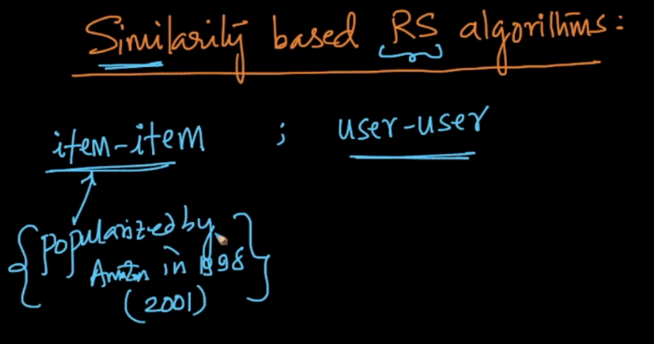

**User-User Similarity:**

From the given matrix where users are on row, and items are on columns.

Let’s assume each user as a column vector, where each value in is items rating.

Now we’ll find the similarity matrix between all the users. Using the cosine similarity between the user vector.

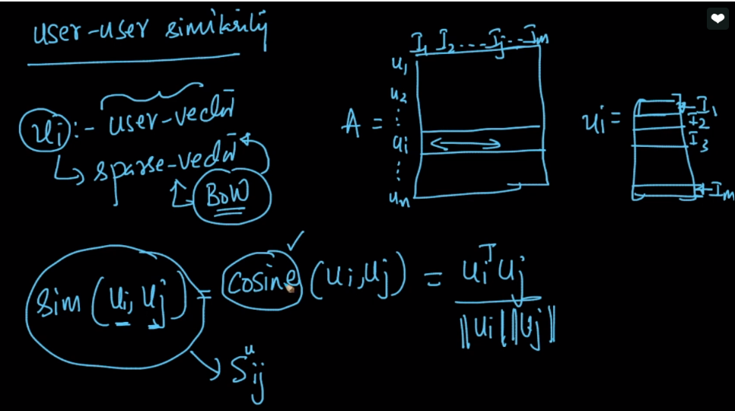

Now we have n*n similarity matrix of users.

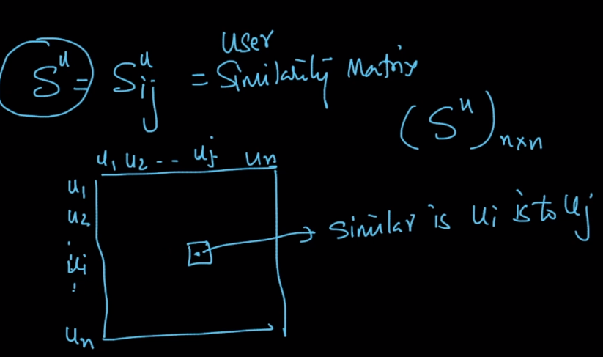

Now the task is to recommend new items to u10, so what we do is find the similar users to u10 using similarity matrix.

Then Pick the items liked by similar users, that are not yet watched by u10.

Then recommend the item to u10.

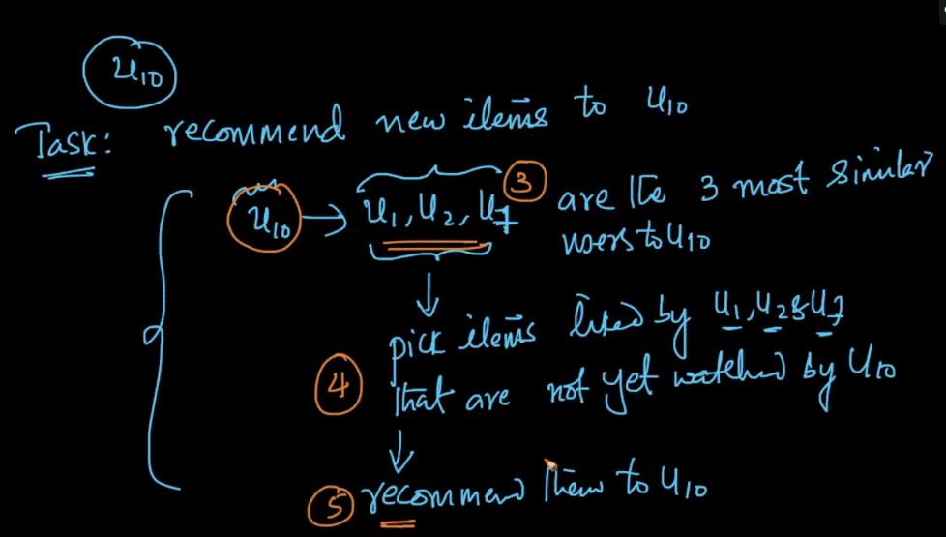

**Problem with user-user similarity.**

Since we know that user’s preferences change over time, like a user on youtube might listen to some other artist after some time.

So in such case user-user similarity cause problem.

However one work around towards this is to use last 90 days matrix.

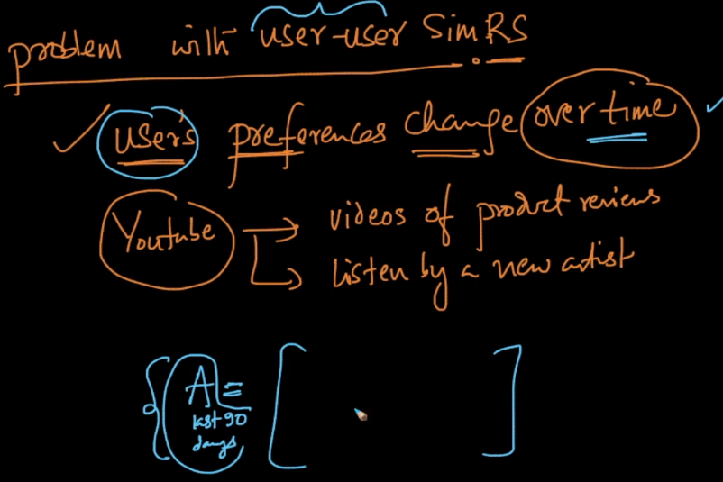

**Item-Item based RS:**

In this also we find similarity using cosine similarity on A matrix but we’ll do w.r.t items.

And since we know that rating on given product/item do not change significantly over time after initial period, there it will not suffer with the problem as in user-user based RS.

Example for titanic, movie rating would not change after sometime and it remains 4.

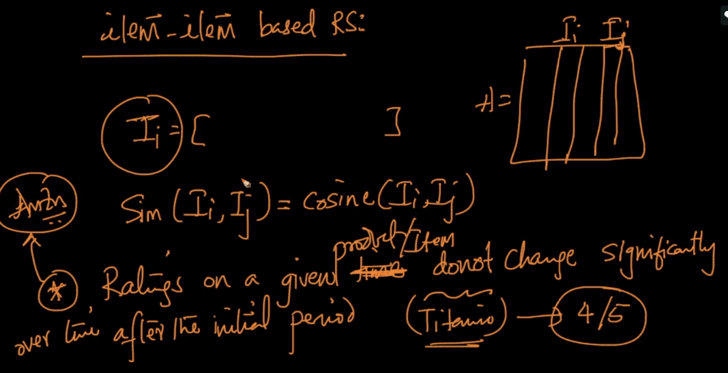

Now how we do recommendation using item-item similarity.

Suppose we need to recommend for u10, then we’ll see which product u10 has rated/watched/bought, suppose u10 has i1, i3, i7 products then we’ll look for the similar products to these products. Now we see the products which is common among all the returns product, suppose i4 is common then we recommend i4 to u10.

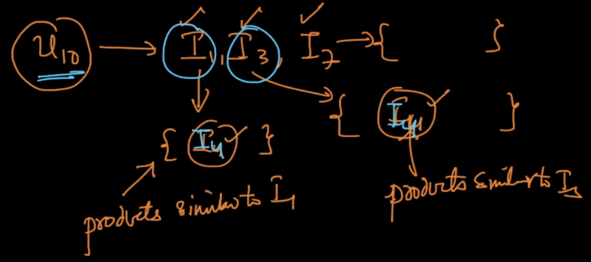

Which to pick among user-user or item-item.

If we have more users than items and item ratings don’t change much over time after initial period the item-item RS should be preferred over user-user RS.

